
IHE Brief Profile Proposal – 2010-2011
Integrating the
Healthcare Enterprise
Proposed Profile | Antepartum Record (APR) Completion Profile  Integration Profiles Affected: APHP, APS, APL and APE
Proposed Editor | Mike Jolley and Tone Southerland
Date | 08/10/2009
Version | 0.1
Domain | Patient Care Coordination (PCC)

The Problem | <Summarize the integration problem. What doesn’t work, or what needs to work.>
There are placeholders throughout the document which need content added to complete the APR profile, these may include the sections below. It is understood that guidance will be provided from PCC Technical Committee on what sections need to be completed.

Volume 1:
- Section 2.7 History of Annual Changes ( What’s new for this year)
- V.1 Scope and Purpose (APR)
- V.3 Actors/Transactions (APR)
- V.4 Options (APR)
- V.5 Groupings (APR)
- V.6 Requirements (APR)
- V.7 Content Modules (APR)
- W.1 Scope and Purpose (APS)
- X.1 Scope and Purpose (APHP)
- Y.1 Scope and Purpose (APE)
- Z.1 Scope and Purpose (APL)
Volume 2:
- 1 - Preface to Volume 2
- 2 - Introduction
- 3 - IHE Transactions
- 4 – IHE Patient Care Coordination Bindings
- 6.1 Conventsions (PCC Content Modules)
- 6.3.1 CDA Document Content Modules
- 6.3.1.1 Medical Documents Specification 1.3.6.1.4.1.19376.1.5.3.1.1.1
- Any missing Sections or Subsections

Key Use Case | <Describe a short use case scenario from the user perspective. The use case should demonstrate the integration/workflow problem. Feel free to add a second use case scenario demonstrating how it “should” work. Try to indicate the people/systems, the tasks they are doing, the information they need, and hopefully where the information should come from.>
Basic Antepartum Record Use Case from Antepartum Summary
This use case reflects the course of care during an uncomplicated pregnancy.
Pre-condition
The patient’s obstetrician sees the patient for her initial and subsequent prenatal visits. During the initial and/or subsequent prenatal visits information is collected and may be updated within the office Electronic Health Record (EHR)
Plans for care
The information collected during the patient’s prenatal visits make up the components which are included in the patient’s Antepartum Record.
Post-condition
The received patient Antepartum Record can be viewed and/or imported into the health information system of the delivering facility to facilitate patient care by healthcare professional at the time of delivery for the mother and newborn.

Standards & Systems | <List existing systems that are/could be involved in the problem/solution. If known, list standards which might be relevant to the solution>
*CCD ASTM/HL7 Continuity of Care Document
*CDAR2 HL7 CDA Release 2.0
* ACOG AR American College of Obstetricians and Gynecologists (ACOG)
Antepartum Record
*LOINC Logical Observation Identifiers, Names and Codes
*SNOMED Systemized Nomenclature for Medicine
*DSG Document Digital Signature
*NAV Notification of Document Availability

Discussion | <If possible, indicate why IHE would be a good venue to solve the problem and what you think IHE should do to solve it.>
- Need to address how to handle Antepartum documents in XDS Folders
- A system needs a way to be able to claim conformance to a set of clinical documents that together make up the Antepartum Record use case – this can be done through the Antepartum Record profile.
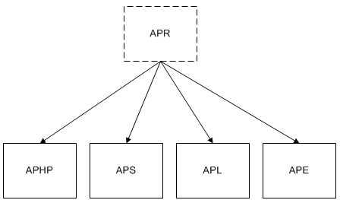

<This [Brief] Profile Proposal must not exceed 2 pages in length>

